- Containerization

Docker file:

# Containerize the go application that we have created
# This is the Dockerfile that we will use to build the image
# and run the container

# Start with a base image
FROM golang:1.21 as base

# Set the working directory inside the container
WORKDIR /app

# Copy the go.mod and go.sum files to the working directory
COPY go.mod ./

# Download all the dependencies
RUN go mod download

# Copy the source code to the working directory
COPY . .

# Build the application
RUN go build -o main .

#######################################################
# Reduce the image size using multi-stage builds
# We will use a distroless image to run the application
FROM gcr.io/distroless/base

# Copy the binary from the previous stage
COPY --from=base /app/main .

# Copy the static files from the previous stage
COPY --from=base /app/static ./static

# Expose the port on which the application will run
EXPOSE 8080

# Command to run the application
CMD ["./main"]

- Test Docker file:
  - docker build -t leemajosephine3/go-web-app:v1 .

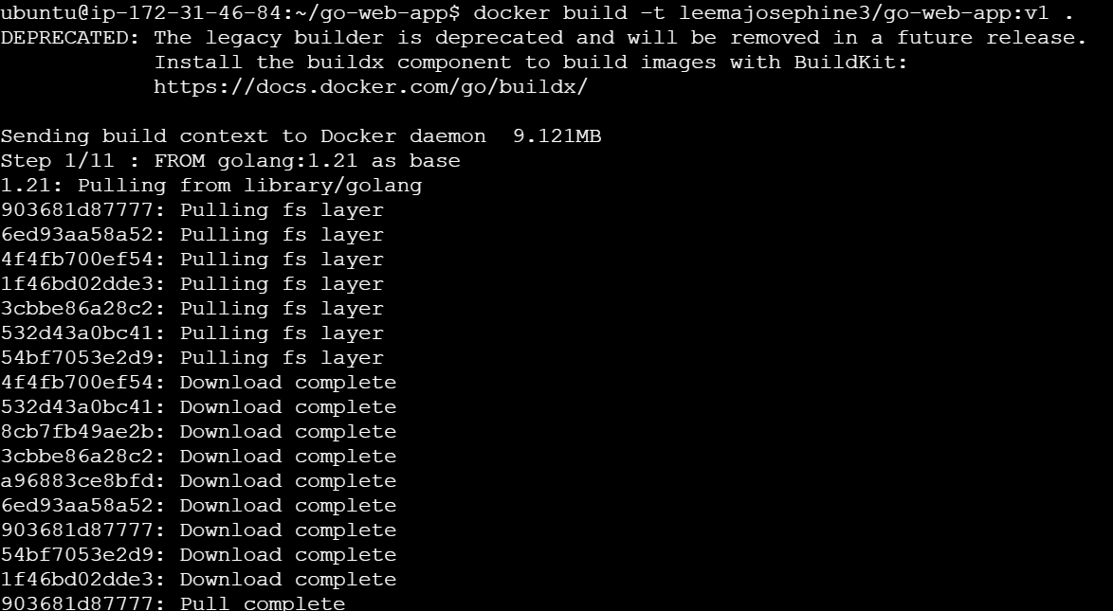

  - Run docker:
- docker run -p 8080:8080 -it leemajosephine3/go-web-app:v1

  - Push the image to registry
- docker push leemajosephine3/go-web-app:v1
- 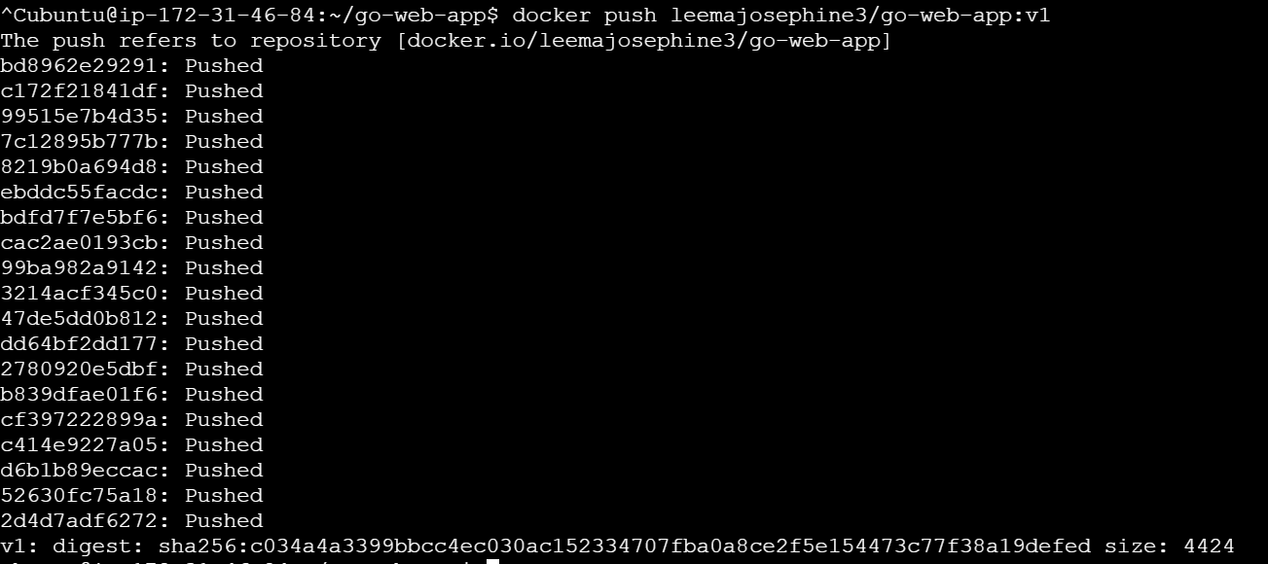
- Kubernetes manifest files:
- Deployment.yaml

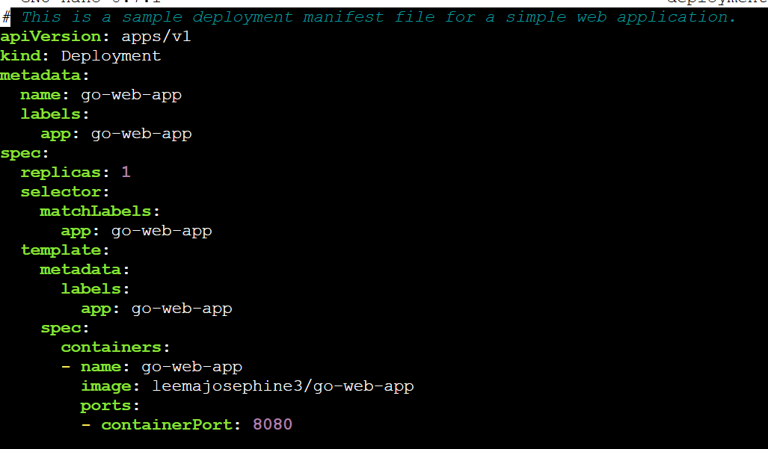

- Service.yaml

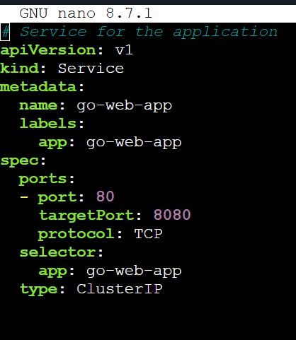

- ingress.yaml

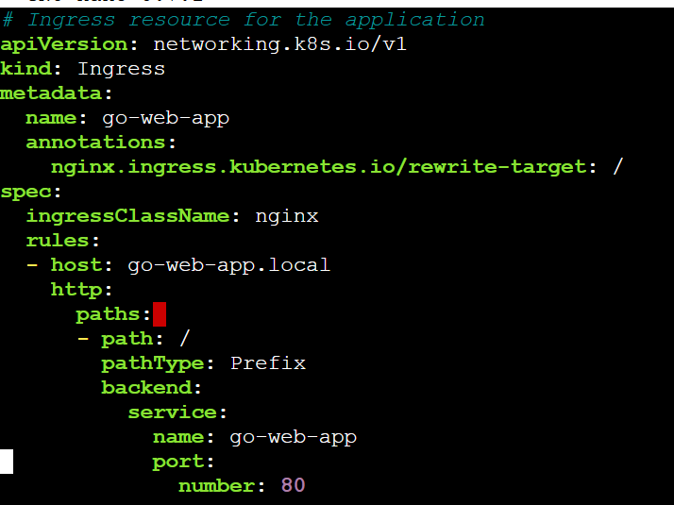

3. Create EKS Cluster
- 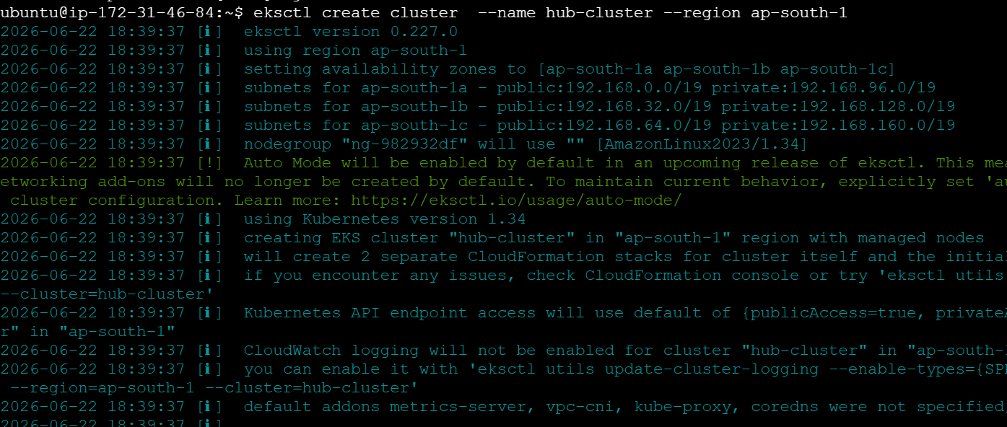

4. Apply kubectl:

- kubectl apply -f k8s/manifests/deployment.yaml
- Verify service:
  - kubectl apply -f k8s/manifests/service.yaml

- Check ingress:
  - kubectl apply -f k8s/manifests/ingress.yaml

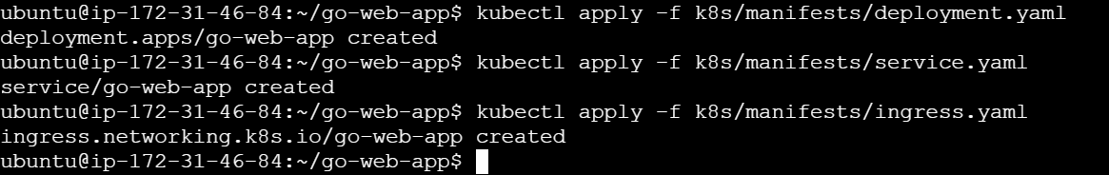

5. Edit service
- kubectl edit svc go-web-app
  - Type: NodePort

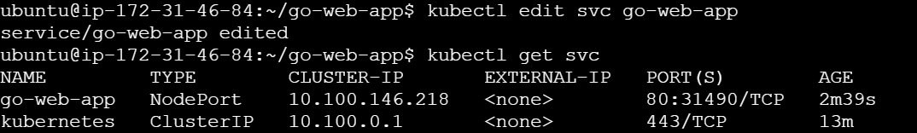

6. Get nodes:
- kubectl get nodes -o wide
- 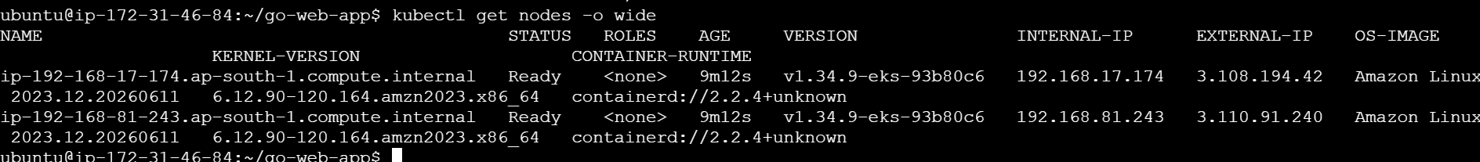

7. Ensure the SG for all the instance has proper Inbound rules:
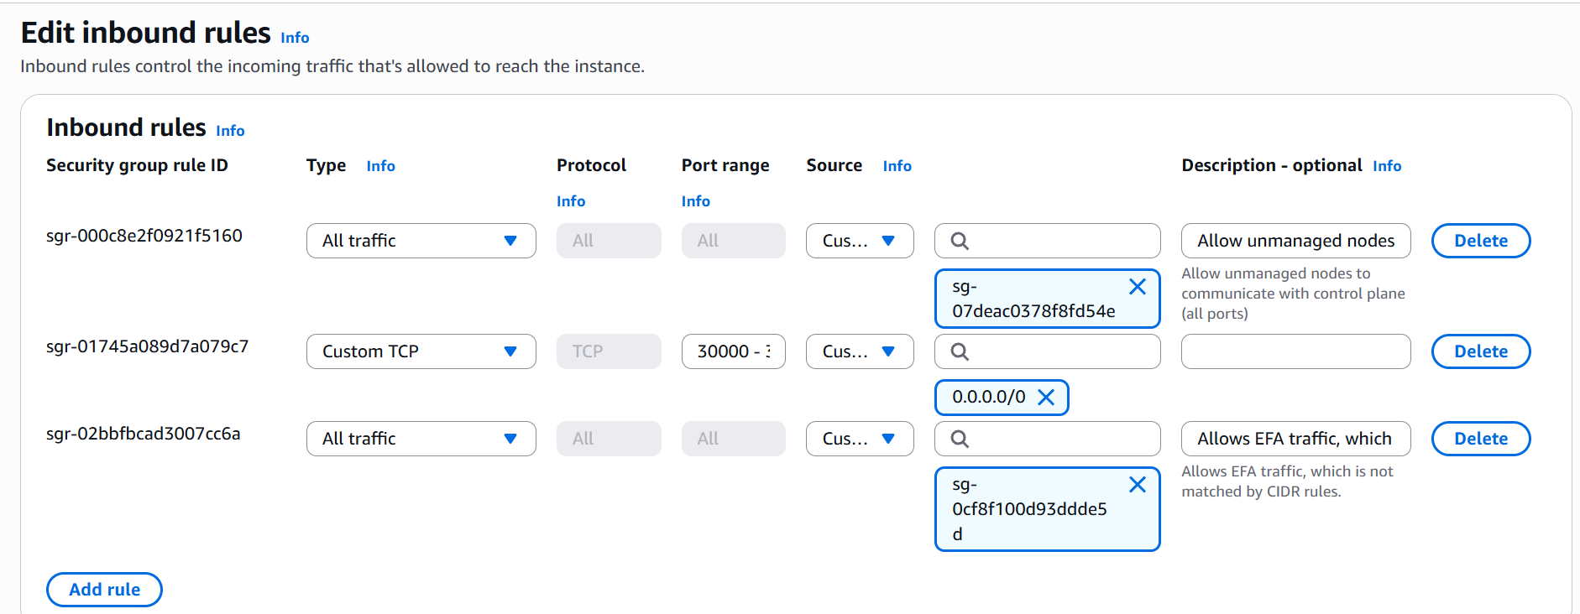

8. Open the browser and combine the external ip and svc port: Application running in kubernetes cluster.
E.g: http://3.110.91.240:31921/courses

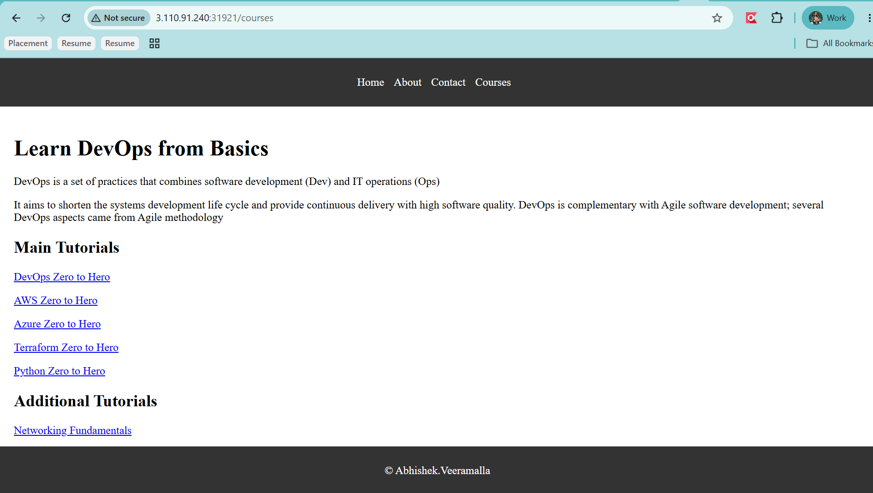

9. Ingress Controller Configuration:

kubectl apply -f https://raw.githubusercontent.com/kubernetes/ingress-nginx/controller-v1.11.1/deploy/static/provider/aws/deploy.yaml

kubectl get pods -n ingress-ngnix
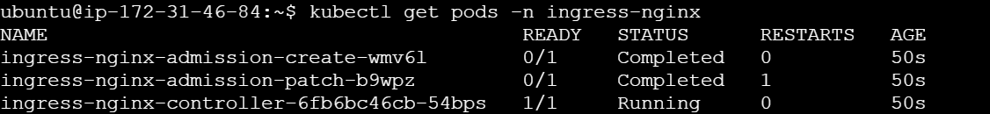

Ingress controller watched for ingress resource and created a load balancer on aws which is Network load balancer.

- kubectl get ing

10. DNS Mapping

In real time we need to map in sudo vim etc/hosts and add the host address.

- kubectl get ingress

Open browser:
- http://go-web-app.3.108.18.91.nip.io/courses

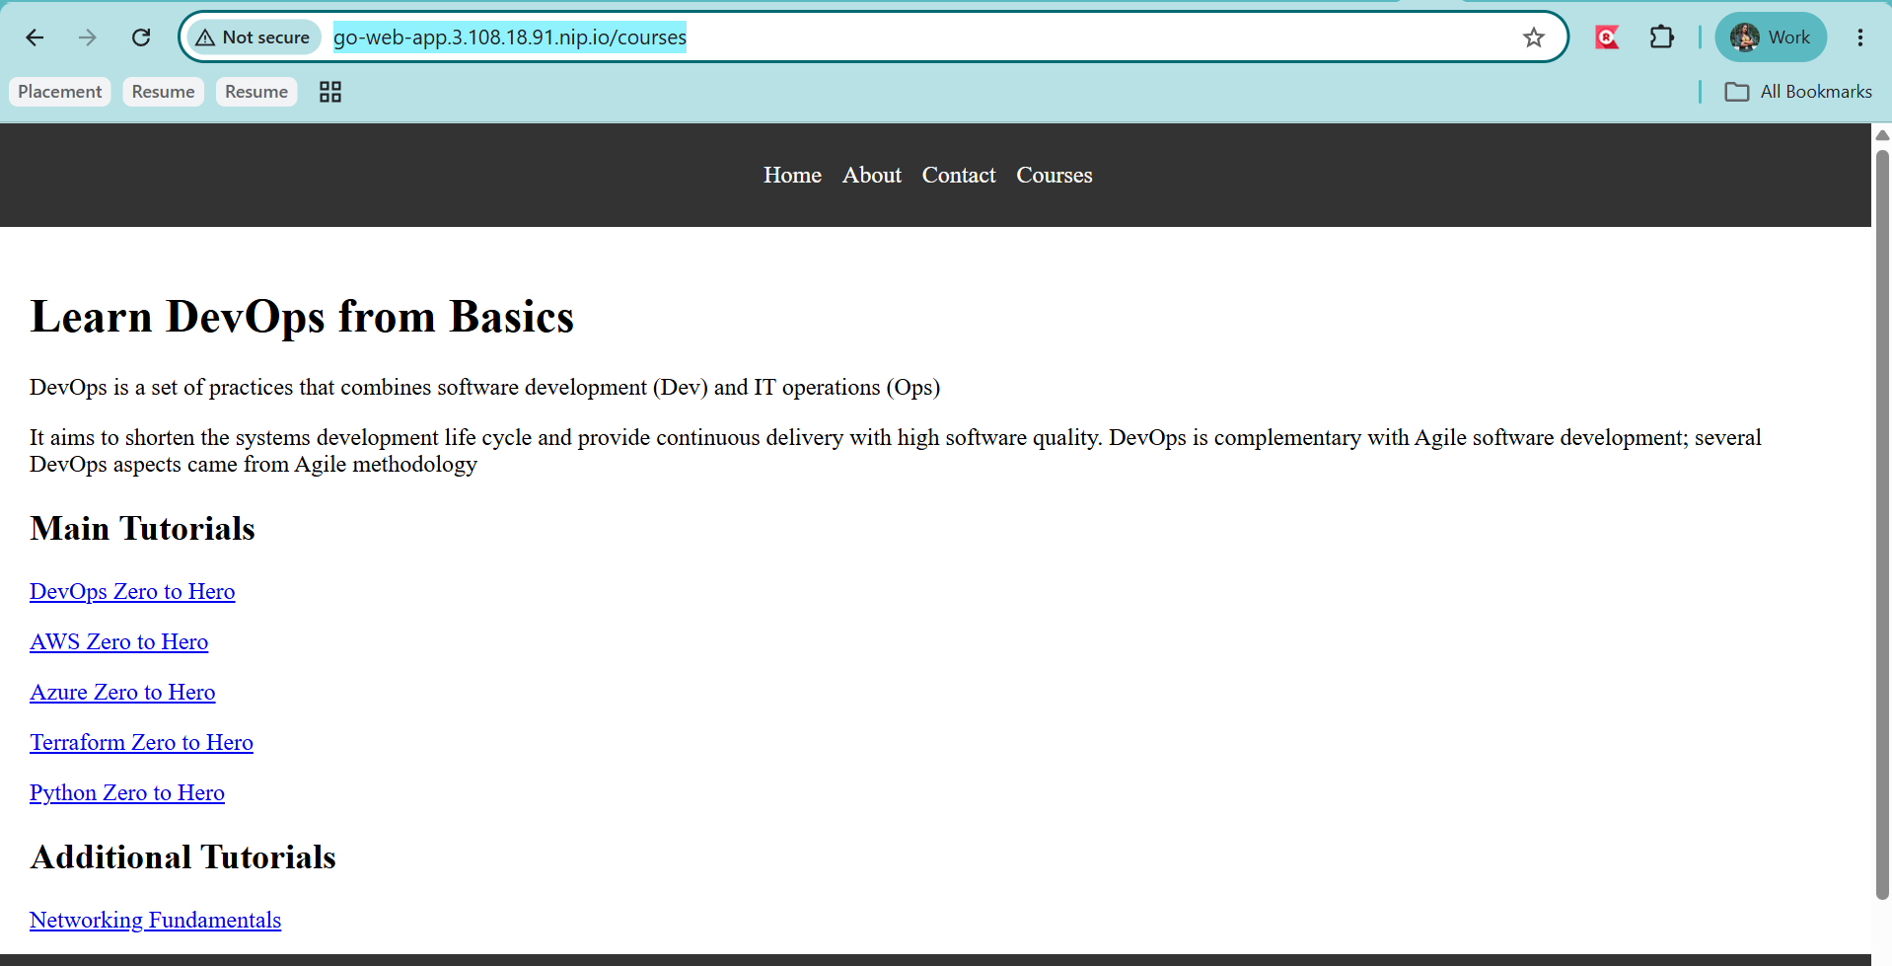

11. Helm chart - We can variabalize the yaml file

- Create helm: helm create go-web-app-chart

Open template and remove everything:
- rm -rf *
- Copy from ks8

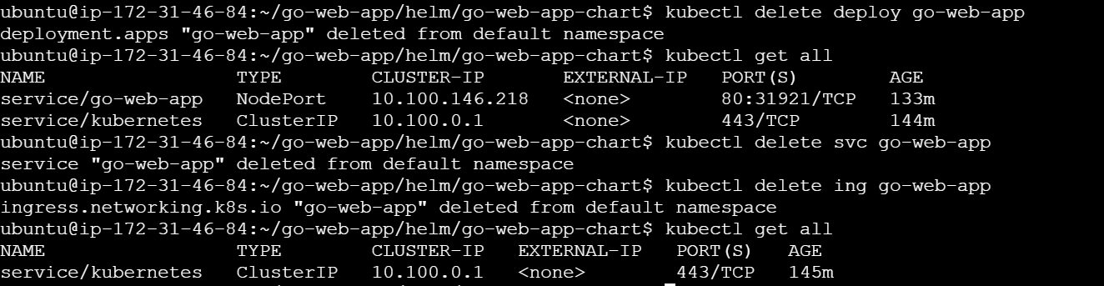

Installing again using helm:
- helm install go-web-app ./go-web-app-chart
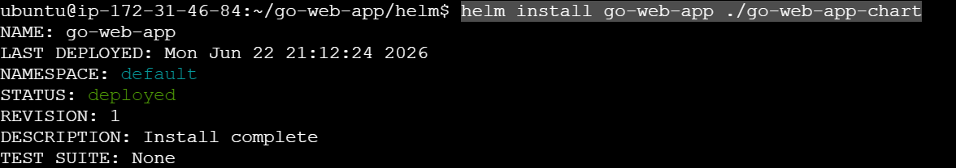
Output:
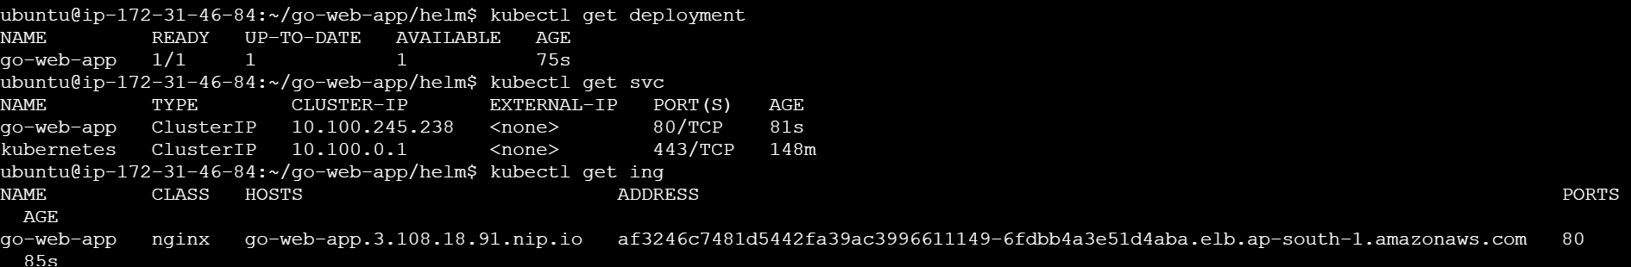

12. CI/CD: CI -> GitHub actions | CD - ArgoCD

Stage 1: Build and Test
Stage 2: Static code analysis
Stage 3: Docker image and push
Stage 4: Update Helm
Stage 5: ArgoCD will pull Helm and so the deployment

Everytime there is going to be a commit, helm values.yaml will trigger ArgoCD will do the deployment.

